**YEAR: 7**

**2023**

**SUBJECT: Science**

**Marking Key for Forms test**

**Semester 2 Term 3**

TEST: Chemistry (Mixture)

## SECTION ONE—MULTIPLE CHOICE (12 marks)

**The multiple-choice questions are self-marking! 😊**

**SECTION TWO: Short Answer**

|  |  |
| --- | --- |
| **MUST STATEMENT**  Describes techniques for separating given materials from a mixture. Identifies pure substances and mixtures from given examples. | **MUST QUESTIONS**  1, 2, 3, 4, 5, 7, 8, 9, 10, 11, 13, 14, 15, 16 |

**Answer the questions in the spaces provided.**

Read the following statements and answer the following questions:

Wax is a solid that does NOT dissolve in water.  
Wax does dissolve in kerosene.  
Sugar does dissolve in water.  
Sugar does NOT dissolve in kerosene.  
Kerosene does NOT dissolve in water (3 marks)

1. **Identify** the solvent you would use to make a solution containing wax.

Kerosene (1)

1. **Identify** two substances that are insoluble in water.

Kerosene & Wax (both for one mark - 1)

1. I**dentify** a substance that is soluble in water.

Sugar (1)

1. Define the following terms:

Pure substance (1 mark)

A single substance that is on its own (1) Can not be separated by physical separation techniques or other acceptable answer.

|  |
| --- |
| Accept ‘substance’ in answer. Don’t accept ‘element’, as compounds can be pure substances. |

1. Colloid (1 mark)

|  |
| --- |
| a homogeneous substance consisting of large or small particles of one substance dispersed through a second substance (1) A mixture that always looks cloudy because insoluble particle remains suspended throughout or other acceptable response |

1. Simple separation (1 mark)

|  |
| --- |
| method that converts a mixture of chemical substances into two or more distinct products (1) or Separating large particles by hand etc. |

1. Graffiti can be covered with oil-based paints, the oil is most commonly linseed oil. Is the paint the: a) solvent b) solute or c) solution? **Explain your answer**. (3 marks)

|  |
| --- |
| Paint is solution (1) |
| Linseed oil is solvent (1) |
| Colours / pigments is solute (1) |

1. You have a mixture of the following substances that need to be separated:

- water  
- iron filings  
- salt  
- wood chips  
- large marbles  
- sand  
Put the separation techniques below into the correct order so that there is only salt remaining. **Will give full marks only if all in correct position. 1 mark per each technique in right order.**

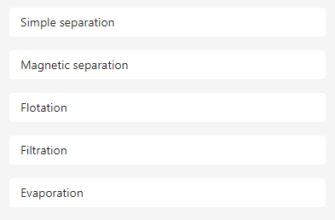

1. Your little sister is watching you put a teaspoon of sugar into a glass of hot water. She makes a comment that ‘the sugar has disappeared”. How do you explain the “disappearance” of the sugar to her? (2 marks)

|  |
| --- |
| Sugar has dissolved (1) process which causes sugar to dissolve such as molecules broken down to smaller parts etc. (1) |

1. List two examples of filtering or sieving used around the home. (2 marks)

Example 1: __________________________________________

Example 2: __________________________________________

Examples can include cooking, tea bags, car application etc. (1 mark for each)

1. Evaporation is a technique used to separate substances.

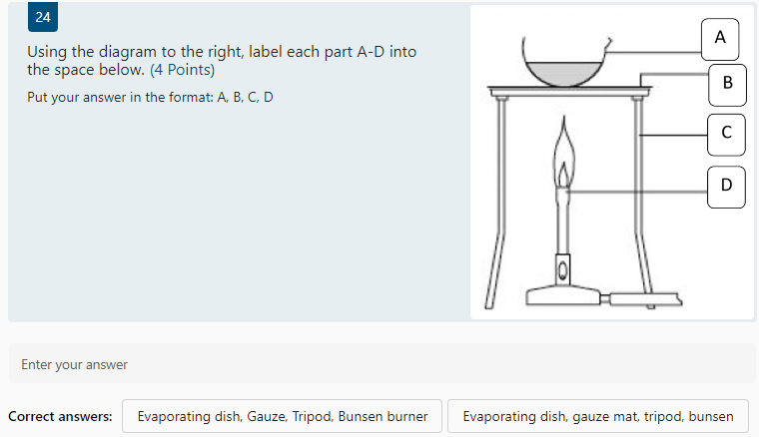

**Question will self-mark if all words spelt correct and correct terminology, please check for suitable answers.**

1. In gold panning, a mixture of gravel and gold particles are swirled around in water and the gold remains in the pan while the gravel is swirled out into the river with some of the water. **Name** and **explain** this separation method. (2 marks)

|  |
| --- |
| This is a method of filtration (1), (then one of ) separating undissolved solid particles from the mixture (1). The heavier, denser gold particles remain at the bottom of the pan while the lighter gravel is swirled out with some of the water (1). |

1. Using an **example**, **explain** how the process by which chromatography can separate substances. (2 marks)

Examples could include, but not limited to: DNA, Covid tests, drug tests, pen ink identification (1) Separates based on the physical properties of the substance (1) such as size of particles, solubility etc. ______________________________________________________________________________________________________________________________________________________________________________

**END OF TEST**

**Please check your work!**